Reading Engagement on social media

Name
Institution
Date

Reading engagement on social media
The rationale for my choice
In my experiment, I decided to use my existing social media account, which is my private Instagram account. There are many reasons for my choice. First, Instagram is my favorite social media platform, and I opened my account long ago, and through it, I have gained a significant number of followers and friends with whom I have a connection. For this reason, I am sure that many of them would definitely read whatever I post. Therefore, I would be able to get different reactions from them as they express themselves openly through their comments and reactions such as likes, comments, and emojis. Also, an active account is ready for the experiment since there is no need to spend a lot of time searching for new followers, which is the case if I had opened another account. Therefore for a timely experiment on reading engagement, a new account is the best choice.
Since the experiment is on social engagement in reading, interactions are needed, and therefore, an already active account would just serve that purpose well since I have been posting about my life on the Instagram account, and my followers have constantly been reacting to my posts. Another reason for choosing my private Instagram account is that most of my friends follow me on Instagram. Therefore, I believe they are the right people to engage with as they care about me and are concerned with my life. The last reason for choosing my private Instagram account is that I have been posting most of my private life activities on it, and therefore, it serves me the best since my planned activities, content material, and engagement are all about my personal life feeling and working experience.

Planned activities
My planned content material and activities were to post non-fiction-related posts about my life as I have recently joined the workforce. Most of the content material I plan to engage my followers is about how my life has significantly changed since I turned in my 20s and started working. I plan to explain to the audience how I have been spending and balancing my time after joining the workforce and, most importantly, on my engagements with colleagues at work. The activities would involve;
- Getting more people to follow my Instagram account
- Connect content with current events
- I engaged followers on how the COVID-19 pandemic has impacted my life.
- Ask specific and pointed questions
- Attach photos in the posts
- Write captivating posts on my Instagram page about my personal life
- Post-non-fiction related posts relating to my experience in the workplace
- Be active on Instagram
- Monitoring the feedback from my followers

Activities undertaken
I was able to undertake most of the activities as planned. The following are the activities I actually managed to undertake throughout the experiment;
- Getting more people to follow my Instagram account - This was the first step that I undertook since I wanted more people to have access to my posts so as to get as much feedback as possible.
- Connect content with current events - I engaged my followers on how the COVID-19 pandemic has impacted my life by explaining how it had changed and interrupted my activities.
- Ask Specific, Pointed Questions - Throughout some of my posts, I posed open-ended questions. This is important as it increases social media engagement and tells whether someone has read the post.
- Sharing photos - In most of my posts, I attached my photo
- Write captivating posts on my Instagram page - I posted captivating stories about my personal life; that is how I was coping with my new job. My planned content material and activities were to post non-fiction-related posts about my life as I have recently joined the workforce.
- Be active on Instagram - I started logging into my Instagram account more frequently than before to monitor the feedback from my posts and respond to their comments.
Visual evidence
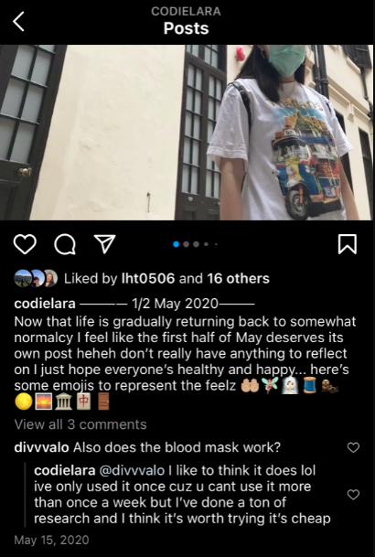

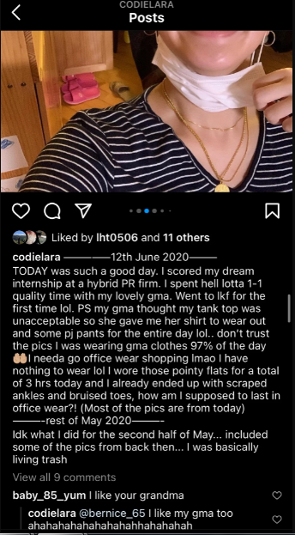

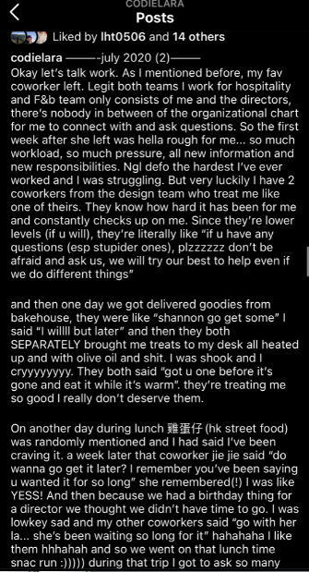

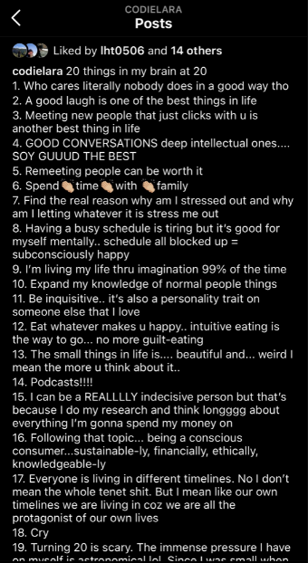

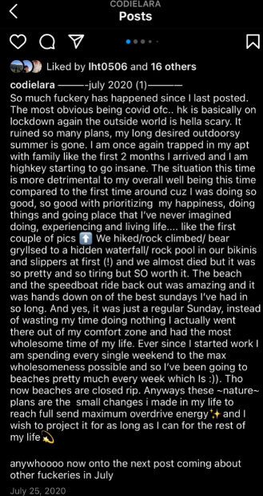

Feedback received
The feedback I got from my friends and followers varied in different ways. In the posts in which I talked about COVID-19, people reacted faster. This is because the topic on COVID-19 interests everyone since it is a current epidemic that has affected our livelihoods; therefore, people are likely to read through the post to better understand how it is affecting me so as they can relate. Also, talking about my job attracted more of my followers to comment since it was a period where some people were losing their jobs. They expressed their frustrations in their comments.
In the post that I posed a question after the end, many people reacted to it in the comment section. Their comments were mainly answering the question that I had posted. This showed that they read the entire post or saw the question first and then started reading it, hence the reaction.
Another thing that made my followers react to my posts is how I started with a captivating first sentence, which prompted many people to read through the entire post, thus reacting more to the posts than my previous ones.
Lastly, the posts to which I had attached my photo got reactions from most of my followers. This is because many people read and engage in content with pictures as visuals attract them. Content without pictures tends to be boring for the readers, and therefore social engagement for readers might be limited.

Overall reflections and considerations
I enjoyed carrying out the experiment, from the planning of the activities to receiving feedback. I was able to engage more with my friends on Instagram and made more friends. The experiment taught me that social media posts with more positive and insightful responses have a greater effect, and interaction with others will make you happier. On the other side, skimming through information on social media platforms, reading or watching without connecting with others, can make people feel even worse.
Followers of social media platforms also expect one to be active, particularly when it comes to offering assistance, which can only be accomplished through a good understanding of the content and effective communication.
Positive interactions on topics that impact the majority of individuals in society are popular to read and share. As a result, posting and answering questions about posts might be considered a kind of advocacy. Responding to comments from followers on social media will encourage you to participate more and, as a result, get feedback on your issues of concern.
One needs to consider post timing as well. Although there is no appropriate time to post for everyone, it is important to consider your audience insights in relation with the post when your followers are most active. When they are active, they are more likely to read through the posts and react.
Curating user-generated content is required to encourage readers to engage with, understand, and share the content. Because the Instagram algorithm takes user relationships into account when ranking material in the feed, building relationships with followers on Instagram might help content rank better in the feed.
According to studies, user-created material is 35 percent more remembered, and 50 percent more trustworthy than traditional media and other non-user provided information. As a result, user-generated content is a worthwhile approach to explore in the twenty-first century to encourage reading in social media.

